**Software Requirements Specification**

**for**

**E-Grocery system**

|  |
| --- |
| Sr.No. Presented By |
|  |
| 1. H. Harshada Balasaheb |
| 1. D. Dhana Lakshmi |
| 1. K. Dileep Kumar |
| 1. S.Dharma Raj |
| 1. Jhoshna |

# Table of Contents

Table of Contents i

1. Introduction 1
   1. Purpose 1
   2. Document Conventions 1
   3. Product Scope 1
   4. overview 1
2. Overall Description 2
   1. Product Perspective 2
   2. Product Functions 2
   3. User Classes and Characteristics 2
   4. Operating Environment 2
   5. Design and Implementation Constraints 2
   6. User Documentation 3
   7. Assumptions and Dependencies 3
3. External Interface Requirements 4
   1. User Interfaces 4
   2. Hardware Interfaces 4
   3. Software Interfaces 4
   4. Communications Interfaces 4
4. System Features 5
   1. Register and Log in 5
   2. Add to Cart and View Cart 5
   3. Confirm Order 5
   4. Add and Update products 6
   5. View Order Details 6
5. Other Nonfunctional Requirements 8
   1. Performance Requirements 8
   2. Security Requirements 8
   3. Software Quality Attributes 8
   4. Business Rules 8

6.Appendix A: Glossary 9

7.Appendix B: Analysis Models 10

8.Conclusion……………………………………………………………………………………..11

1. **Introduction**

## Purpose

The aim of this document is to gather and analyze and give an in-depth insight of the complete **E-Grocery system** by defining the problem statement in detail. The project aims to develop a web-based application to improve the service to the customers and merchant which in turn increases the sales and profit in "online shopping". The detailed requirements of the **E-Grocery System** are provided in this document.

## Document Conventions

This document follows MLA Format. Bold-faced text has been used to emphasize section and sub-section headings. Italicized text is used to label and recognize diagrams.

## Product Scope

This system allows the customers to maintain their cart by adding or removing the product. It allows online sales, distribution and marketing of goods.

**1.4 Overview:**

This system provides an easy solution for customers to buy the product without going to the shop and also to shop owner to sale the product.

This proposed system can be used by any naïve users and it does not require any educational level, experience or technical expertise in computer field but it will be of good use if user has the good knowledge of how to operate a computer.

1. **Overall Description**

## 2. Product Perspective

The E-Grocery system should provide the facility of ‘Buying’ of items. There is no credit card payment. Payment is assumed to be by ‘Cash on Delivery’.

This product aimed towards people who wish to save time and energy by not going to the shop instead ordering for products sitting at home. Also some products may not be available in the store a person visits; the proposed system is a solution to carry out buying/selling products online.

## Product Functions

* Access to the E-Grocery system for the administration and the customer is provided with individual login.
* Username will be individual customer id and each set their own password.
* Only the administer can add or update the database containing the products.
* Customer can only view the item details and order items that they choose to buy.

The system allows the user to buy/sell products online.

## 2.2 User Classes and Characteristics

There are 2 kinds of users for the proposed system.

* + - Administrators: Administrators are the ones who adds or administers the products.
    - End Users/Customers: The end user will be the one who visits the website and buys products online from the ones added by the administrator.

## 2.3 Operating Environment

### Hardware Requirements

A PC with proper speed and memory.

### Software Requirements

Front End: PHP: HTML, CSS, JavaScript.

Back End: SQL Database.

* 1. **Design and Implementable Constraints**
     + The main constraint here would be the checking the genuineness of the buyer, which is not always possible. There can be security risks involved.
     + The developed system should run under any platform (Unix, Linux, Mac, Windows etc.) that contains a web browser which supports PHP, HTML, CSS, JavaScript, React and SQL database.
     + MySQL should be available in the local host.
     + The website is not published on the internet. It is run on the local host itself.
     + Real life credit card verification and banking system is not implemented.

## Assumptions and Dependencies

Administrator is created in the system already. The manager cannot be a customer. Any user cannot edit their account information. The details related to the product, customer payment and service transaction is provided manually. Roles and tasks are predefined.

1. **External Interface Requirements**

## 3.1 User Interfaces

Each part of the user interface intends to be as user friendly as possible. The fonts and buttons used will be intended to be very fast and easy to load on web pages. The pages will be kept light in space so that it won’t take a long time for the page to load.

The starting page will be the home page of the store. All the products available are displayed. An ‘Add to Cart’ button is available which will add the product by the specified quantity given in the text box to the cart only if the user is logged in to his/her account.

A logged in user can also view the items in the cart and buy them. There are pages which displays the details accordingly.

**3.2 Hardware Interfaces**Processor: - Pentium I or above. RAM: - 128 MB or above.

HD: - 20 GB or above.

NIC: - For each party.

## 3.3 Software Interfaces

The following are needed requirements.

**Operating System:** Unix, Linux, Mac, Windows etc. **Development tool:** PHP, JavaScript, Ajax

**Application:** XAMPP application

**Data Base:** MySQL Database Server

**3.4 Communication Interfaces**

PHP uses session variables to communicate between pages of the website.

1. **System Features**

## Register and Log in

* + 1. **Description and Priority**

This feature creates an account for a new user in the system. For a user to be able to buy any item he/she must have an account and must be logged into it. This feature enlists the user details in the database. This is an important feature so it has high priority.

* + 1. **Stimulus/Response Sequences**

Customer first clicks on the button or link to initiate registration process. The system then prompts the customer to fill out his/her first name, last name, shipping address, email address, and their password. Customer enters the fields. System validates the customer's information and creates a new account for the Customer.

Once a customer register, he/she clicks on the log in button to initiate the login process. The system prompts the customer for his/her email and password and verifies the information. After verification the system displays account home page to the Customer.

* + 1. **Functional Requirements**

REQ-1: A button for register and log in must be available REQ-2: A table in the database must be created for all users.

## Add to Cart and View Cart

* + 1. **Description and Priority**

This feature enables for a user to browse through different products in the home page and add any product to the cart. The user can also specify the quantity he/she wants to add to the cart.

On ‘View Cart’ the user must be able to see all the items in his/her cart.

* + 1. **Stimulus/Response Sequences**

If enough quantity is not available then a message informing the same must be displayed else the item is added to the cart of the user.

* + 1. **Functional Requirements**

REQ-1: A button for adding to cart.

REQ-2: A button for viewing items in cart.

REQ-3: A table in the database must be created having all the product available and each product’s details must be present.

REQ-4: A table for items added to cart must also be available

## Confirm Order

* + 1. **Description and Priority**

This feature confirms the order placed by the customer i.e., now the customer has brought the product. Card payment is not available.

* + 1. **Stimulus/Response Sequences**

Customer clicks the button or link to initiate the confirmation process. Customer confirms the order. System stores order confirmation and order details and prints the bill.

* + 1. **Functional Requirements**

REQ-1: A template/window dealing with the items ordered must be created.

REQ-2: The table dealing with the products must be updated i.e., the quantity of the product bought must be decreased by the quantity bought once billing is done.

REQ-3: A table dealing with all the orders by different customers must be maintained.

## Add and Update Products

* + 1. **Description and Priority**

This feature is available only for the administrator. Only the administrator can add products and update details of the product in the database.

* + 1. **Stimulus/Response Sequences**

Administrator clicks the button to initiate Add Product process. The system prompts the administrator to fill out product details. System validates the new product information and adds it to the database.

Administrator clicks the button to initiate Update Product process. The system prompts the administrator to fill out product ID. The corresponding product details are displayed. The admin can update any value except the ID of the product. System validates the new product information and update it in the database.

* + 1. **Functional Requirements**

REQ-1: A separate log in for the administrator must be created. REQ-2: An administrator cannot buy a product.

## View Order Details

* + 1. **Description and Priority**

This feature is available only for the administrator. Only the administrator can view the order details of all users.

* + 1. **Stimulus/Response Sequences**

Administrator clicks the button to initiate View Order Table process. Details of each customer and his/her order details are printed.

* + 1. **Functional Requirements**

REQ-1: A separate log in for the administrator must be created. REQ-2: An administrator cannot buy a product.

REQ-3: An administrator cannot change the order details table.

1. **Other Non-functional Requirements**

## Performance Requirements

Maximum possible quick response to the orders is required, also should provide fast updating of records. The changes if any made should be reflected automatically in the next screens.

In order to maintain an acceptable speed at maximum number of uploads allowed from a particular customer as any number of users can access to the system at any time. Also, the connections to the servers will be based on the attributes of the user like his location and server will be working 24X7 times.

* 1. **Safety Requirements**

The application is password protected and also any updating of new product entries and order processing is done by only privileged users.

## Software Quality Attributes

The necessary qualities of software products are

* + 1. Security:

The application is password protected and also any updating of new product entries and order processing is done by only privileged users.

* + 1. Maintainability:

The application is to be designed so that it is easily maintained. Also, it should allow incorporating new requirements in any module of system.

* + 1. Reliability:

The application will be able to handle two orders. When a user confirms his/her order the database will be updated immediately and the next user will not face problems in ordering.

* + 1. Portability

The application will be easily portable on any window-based system.

## Business Rules

Only the admin can add products in the database. The user can only search and buy for the products added by the admin. The admin cannot buy products.

# Appendix A: Glossary

HTTP Hyper Text Transfer Protocol SQL Structured Query Language GUI Graphical User Interface

SRS Software Requirements Specification CSS Cascading Style Sheet

PHP a server-side scripting language designed for web development (Hypertext Pre-processor)

1. **Appendix B: Analysis Models**
2. **Use Case Diagram**

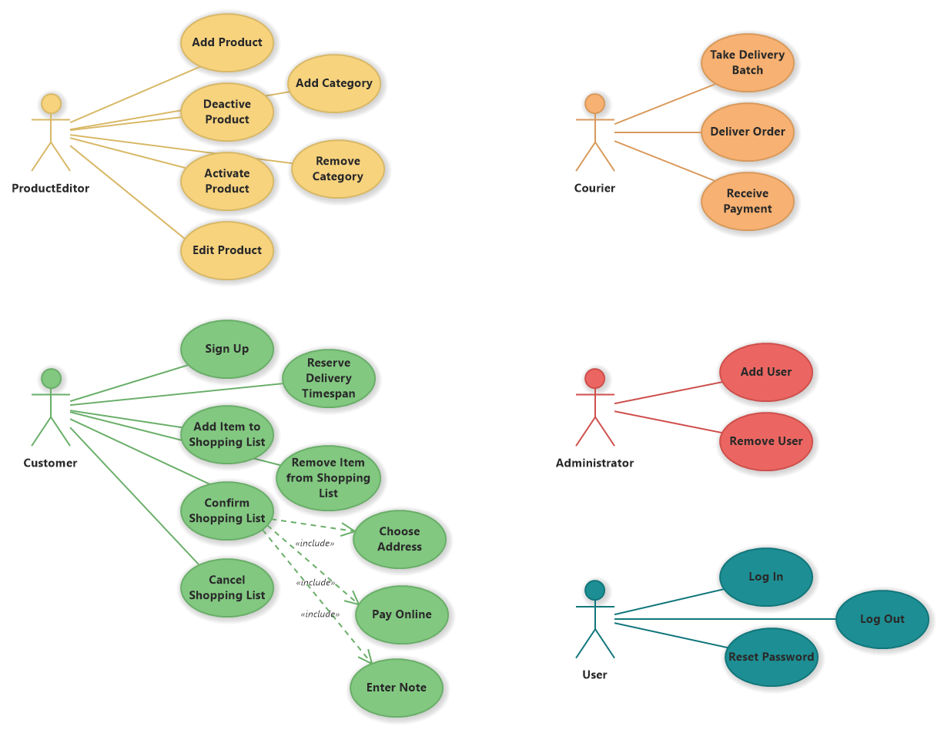

1. **Activity Diagram**

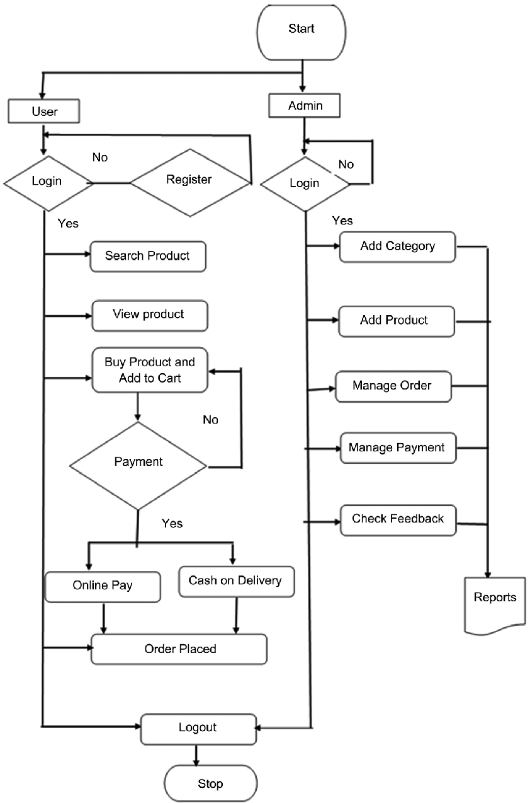

* **Activity Diagram for users**

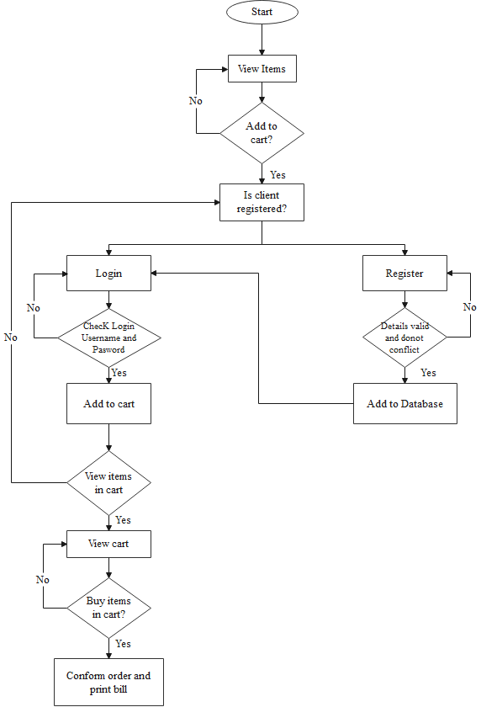

* **Activity Diagram for Admin**

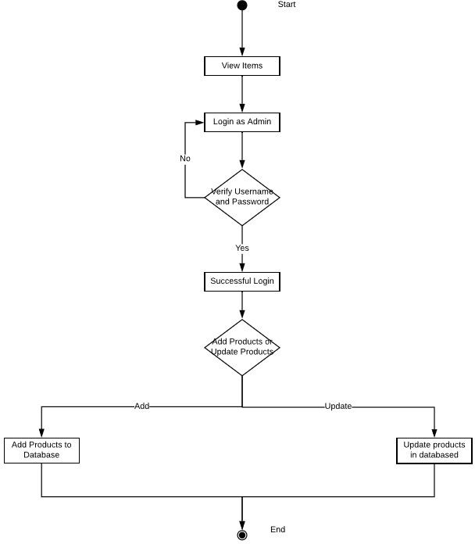

1. **Navigation Diagram**

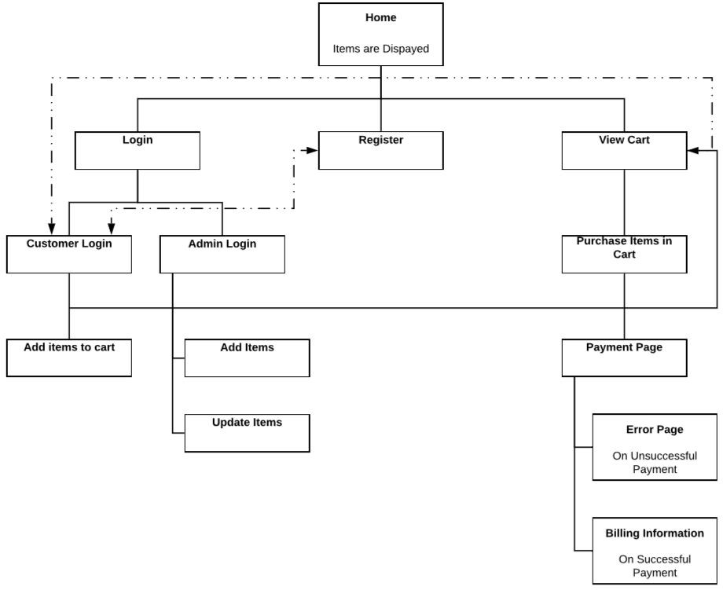

1. **Overall System Architecture Diagram**

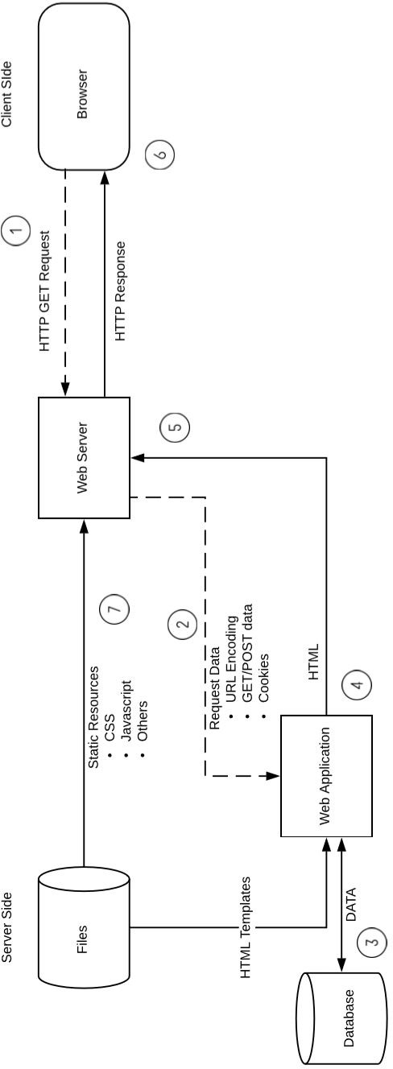

1. **Sequence Diagram**

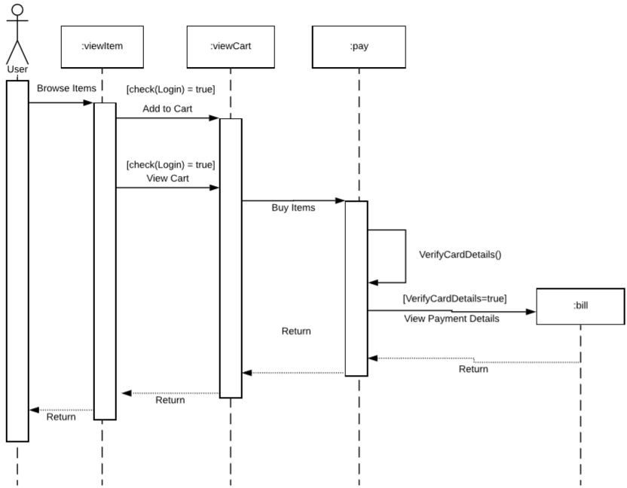

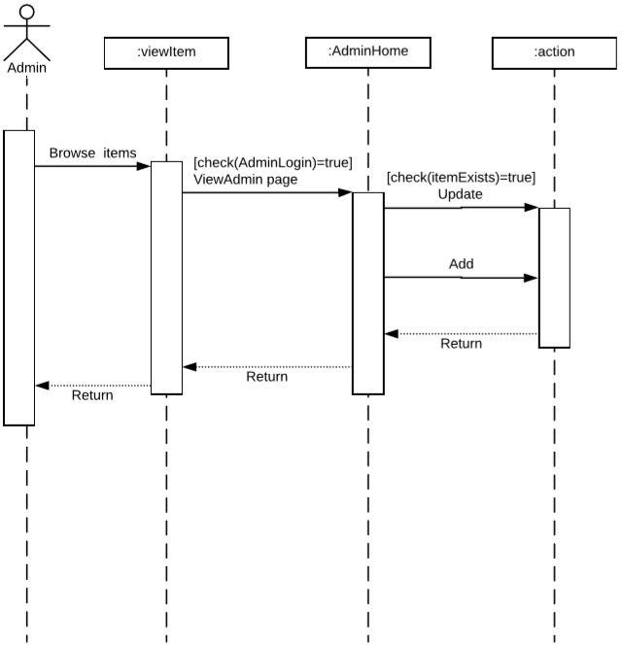

1. **ER (Entity Relationship) Diagram**

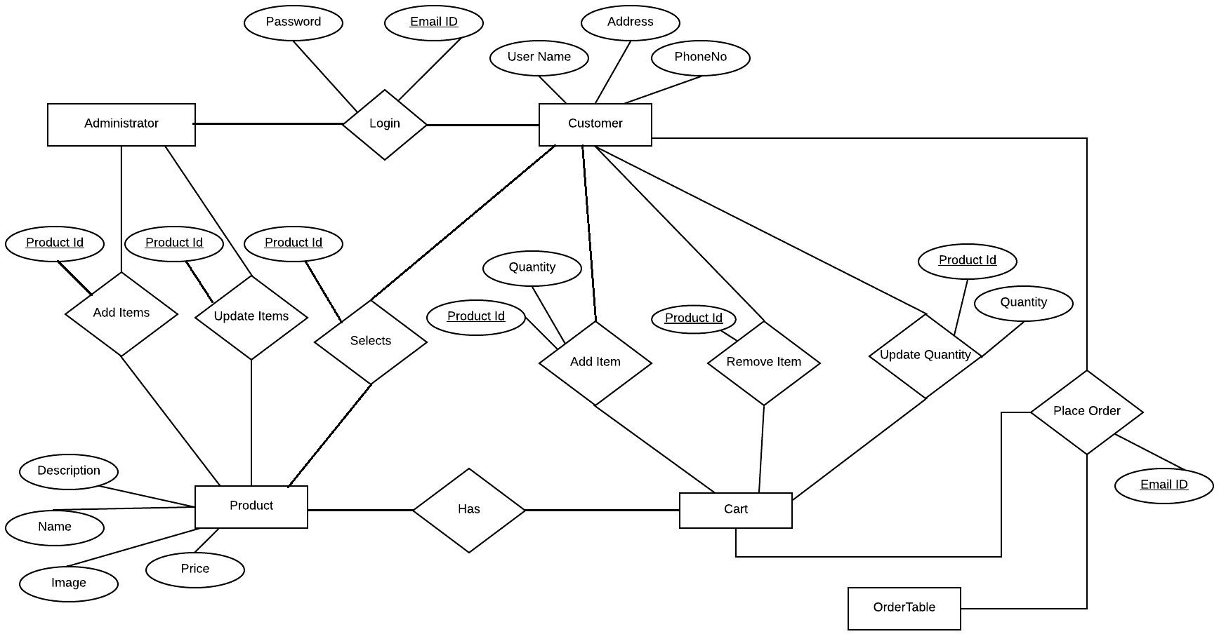

1. **Conclusion**

Technology has made significant progress over the years to provide consumers a better online shopping experience and will continue to do so for years to come. With the rapid growth of products and brands, people have speculated that online shopping will overtake in-store shopping.  While this has been the case in some areas, there is still demand for brick-and-mortar stores in market areas where the consumer feels more comfortable seeing and touching the product being bought.  However, the availability of online shopping has produced a more educated consumer that can shop around with relative ease without having to spend a large amount of time.  In exchange, online shopping has opened up doors to many small retailers that would never be in business if they had to incur the high cost of owning a brick-and-mortar store.  At the end, it has been a win-win situation for both consumer and sellers.